Test Charter 1
Date: 12/08/23
Tester: Matt Mewis
Test Charter:
Explore the 'Number of Units Required' field on the buy energy form
With different data sets
To discover if energy quantity values are validated before being submitted
Consider:
- Numeric values
- Alphanumeric values
- Special characters
- Negative values
- 0 value
- Value above the maximum available quantity
Testing Notes
I tested the 'Number of Units Required' field for the Gas energy type
The default quantity was 0, I made no change and clicked 'Buy'. Result: No validation failure (not expected)
I entered a quantity between 1 and 3000. Clicked 'Buy': Result: No validation failure (expected)
I entered a negative quantity, -10, and clicked 'Buy': Result: No validation failure. The available quantity rose by the +10. (not expected)
I entered a number that was above the maximum available quantity, 5000. Result: No validation Failure. The available quantity of the energy type changed to -2000 (not expected)
I then selected 'Buy' when no value was in the field at all. Result: An error page appeared. This stated "An error occurred while processing your request - Input string was not in a correct format.".
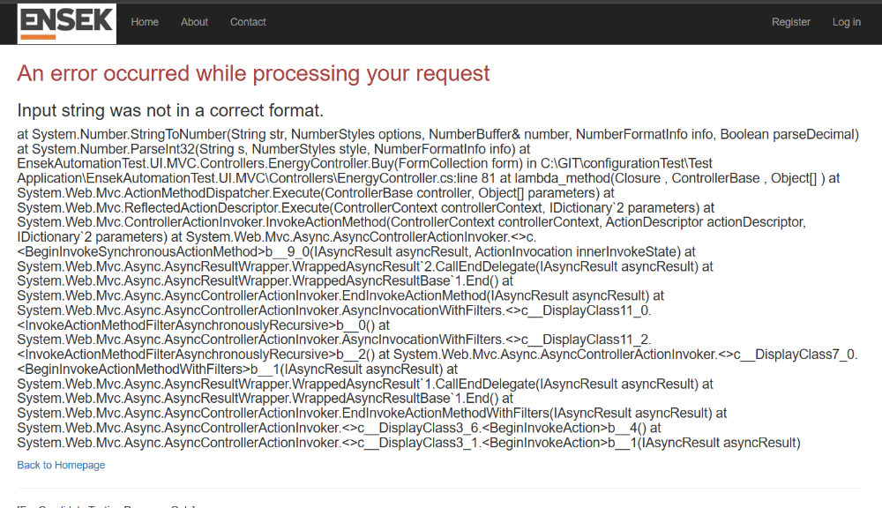

It also showed a stack trace, which may expose information that a hacker could use to identify a vector to exploit the underlying system.
I then entered a quantity of 'test' and clicked 'Buy'. Result: Unfriendly error - the same as in the above screenshot.
Next I entered <script>alert</script> into the field and clicked 'Buy'. this was an attempted XXS attack. Result: No validation (not expected). The system detected the danger (good) but threw an unfriendly error.
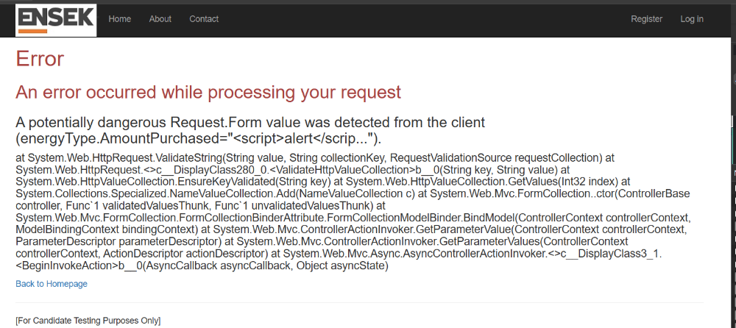

I then entered a numeric value that was very long. Result: No validation (not expected). This resulted in the below unfriendly error:
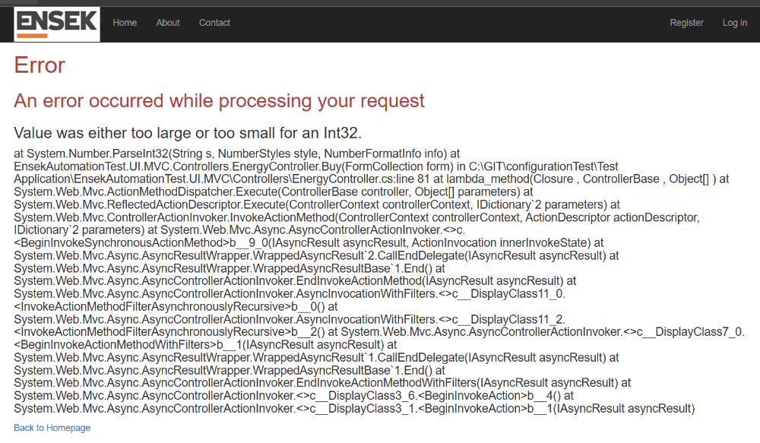
The tests noted above were against the 'Gas' type field.
I replicated each issue against the 'electricity' type and 'Oil' types. the same issues were present.
Issues:
A common theme for all issues below is - there is no field validation. This results in undesirable behaviour and unfriendly error messages.
1. No validation against a 0 value. This is not a valid transaction as nothing was purchased.
2. A user can enter and successfully submit a negative number. This then increases the available quantity for the energy type selected. Negative numbers should not be able to be submitted.
3. User able to enter a value of 5000, 2000 above the maximum quantity available for the energy type. This made the energy type -2000. This does not feel right as you cannot purchase more than is available.
4.User is able to select 'Buy' when no value is in a field resulting in an unfriendly error.
5. User is able to input the text 'test' and select 'Buy' when no value is in a field resulting in an unfriendly error. This appears to happen with any non-numeric value (other than -)
6. No validation in place to prevent me entering a potentially dangerous string. This resulted in an unfriendly error.
7. No validation to prevent a very large number being submitted. This resulted in an unfriendly error message.
8. Unfriendly error messages can confuse users and reduce a users confidence in a website/system. It may expose too much information to a potential attacker, increasing risk to the system and the wider organisation.
Bug #1 created covering the lack of validation

